Vertebrae

DATE: _____________ LAST NAME: _________________ FIRST NAME: ______________________

DATE OF BIRTH ____________________ MALE / FEMALE
AGE_________________ CELL NUMBER ____________________________
ADDRESS _________________________________________________________________________________
CITY ___________________________ STATE ________________________ ZIP ________________________
EMAIL ___________________________________________________________________________________

OCCUPATION ___________________________ EMPLOYED BY ____________________________________

EMERGENCY CONTACT________________________________ PHONE________________________________

HOW DID YOU HEAR ABOUT VERTEBRAE? ________________________________________________
HAVE YOU EVER HAD CHIROPRACTIC CARE BEFORE? YES / NO
If yes, when, where? ________________________________________________________________
HAVE YOU BEEN IN A CAR ACCIDENT IN THE LAST 6 MONTHS? YES / NO

Minor Child Consent
I _________________________________________ being the parent or legal guardian of _______________________________________ (Children's Names) have read and fully understand the terms of acceptance and hereby grant permission for my child(ren) to receive chiropractic treatment.

Front Back
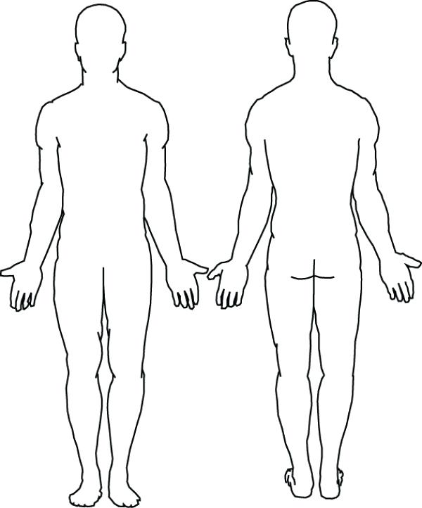
Name _________________________ Date ____________
Reason for visiting us today________________________________________
How long has this been a problem? _______________________________
Does anything make it better? ___________________________________
Does anything make it worse? ___________________________________
Does the pain radiate? _______ If so, where? ________________________________
Daily water intake (oz)? 8 16 24 36 64 MORE____________
Are you allergic to anything? ________________________________________________________________

Rate your pain/discomfort level on a scale of 0-10:
0 1 2 3 4 5 6 7 8 9 10
(10 being the highest) (Also, rate your lowest pain level)

Circle the type of pain/discomfort that you have:
Sharp Tingling
Dizziness Aching (Please indicate the location of your
Throbbing Numbness pain on the figures up above.)
Stabbing Burning

History
Please check all that apply

- Headaches
- Migraines
- Neck pain
- Numbness, tingling pain in arms, hands, fingers, or face
- Hip
- Lower back pain/ stiffness
- Shoulder pain
- Upper back/stiffness
- Stroke
- Cardiovascular Issues

DO YOU SMOKE? YES / NO
ARE YOU ON BIRTH CONTROL? YES / NO
Broken bones? If yes, please explain ___________________________________________________
Please list any Surgeries _____________________________________________________________
Have you ever been Hospitalized ______________________________________________________
Current Medical Conditions___________________________________________________________
Past Medical Conditions _____________________________________________________________
Family Medical Conditions ___________________________________________________________
Current Medications ________________________________________________________________

Patient Privacy, Informed Consent and Non-billing Statement
Requested Restrictions on Certain Disclosures of Health Information: In the case that an individual request under paragraph (a)(1)(i)(A) of section 164.522 of title 45, Code of Federal Regulation, that a covered entity restrict the disclosure of the protected health information of the individual, notwithstanding paragraph (a)(l)(ii) of such section, the covered entity must comply with the requested restriction if:
- I give Vertebrae permission to provide chiropractic services to me in an open bay area (room) where other patients are being treated. I am aware that other persons in the office may overhear some of my protected health information during the course of my treatment. The Doctor can provide a private room for any discussions that are necessary too not be overheard.
- I give Vertebrae and all its clinics operating under the common law name of Vertebrae permission to access my patient care records in accordance with all applicable laws.
- The protected health information pertains solely to a health care item or service for which the health care provider involved has been paid out-of-pocket in full.
- I understand and am informed that some risks are associated with chiropractic adjustments, including, but not limited to, sprains, dislocations, fractures, disc injuries, strokes and paralysis.
- I give permission to Vertebrae to use my address, phone number and clinical records to contact me with notifications, birthday cards, holiday related cards, information about treatment alternatives, or other health relation information.
- If Vertebrae contacts me by phone, I give them permission to leave a message on my answering machine or voicemail.

(Patient's Printed Name) hereby direct that Vertebrae shall not submit any billing data or related claim(s) for, or on, my behalf to any private insurance program, Medicare or any Secondary Medicare Insurance Program, carrier with whom I have insurance services provided to me at Vertebrae. By signing this form, you understand the informed consent and are giving permission to use and disclose your protected health information in accordance with the directives listed.

(Patient Signature) (Date)

Informed Consent to Ancillary Treatments

In addition to chiropractic adjustments, we may consider using additional treatments. These treatments may involve the following significant risks:

- Cryotherapy (skin reactions)
- Traction (Aggravation of present condition)
- Intersegmental Traction (Aggravation of present condition)
- Myofascial Release/Massage Therapy (Bruising, release of emboli)
- Vibratory Massage (Thumper/Percussor)
- Heat (1st & 2nd degree burns, hemorrhage)
- Ultrasound (Periosteal burn, skin reactions)
- Interferential IFC (Bruising, skin reaction)
- Flexion-Distraction Therapy (Aggravation of present condition)
- Bemer Physical Vascular Therapy
- B-12 Vitamin Shot (Some redness and/or swelling at the injection site)
- Glutathione Shot (Some redness and/or swelling at the injection site)
- Trigger point Injection (Muscle soreness, muscle spasms in neck and shoulders)
- X-Rays (Exposure to high radiation levels)

Having been informed of the risks of the above checked Ancillary Treatments, I hereby give my consent to Vertebrae Clinics to perform the treatment and acknowledge that no guarantee or assurance as to the results that may be obtained from this treatment has been given to me.

____________________________________ ________________________
(Patient Signature) (Date)

Terms of Agreement

When a patient seeks chiropractic health care and we accept a patient for such care, it is essential for both to be working towards the same objective. Chiropractic has only one goal. It is important that each patient understand both the objective and the method that will be used to attain it. This will prevent confusion or disappointment.
Adjustment: An adjustment is the specific application of forces to facilitate the body's correction of vertebral subluxation. Our chiropractic method is the diversified approach. Diversified is the technique that generally results in the popping sound as the chiropractor makes a manual adjustment to correct misaligned or subluxated spinal segments of the neck or back and is one of the most widely used forms of manipulation in the chiropractic field.
Vertebral Subluxation: is when one or more of the bones of your spine (vertebrae) move out of position and create pressure on or irritate spinal nerves. Spinal nerves are the nerves that come out from between each of the bones in your spine. This pressure or irritation on the nerves then causes those nerves to malfunction and interfere with the signals traveling over those nerves.
We do not offer to diagnose or treat any disease or condition other than vertebral subluxation. If any unusual findings are found during any examination by our Doctors at Vertebrae, we will inform you of these finding and help you find a place that will better fit your needs for care.
By signing below, I have read and fully understand the above statements. All questions regarding the doctor's objectives pertaining to my care in this office have been answered to my complete satisfaction. I therefore accept chiropractic care on this basis.

_____________________________________________________ __________________
(Patient Signature) | (Date)
__________________________________________________ _________________
(Vertebrae Representative) (Date)
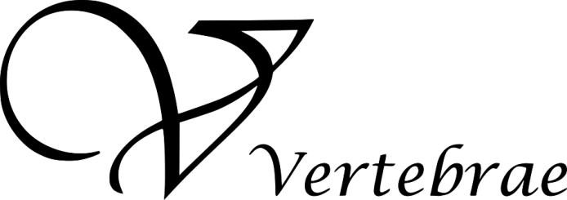

(TAKE ME)

Glutathione Injections - $25 (single) / $99 (package of 5)
Glutathione is a tripeptide made from glycine, glutamine, and cysteine. It is a great antioxidant that reduces overall oxidative stress and reactive oxygen species. It can help reduce chronic inflammation that is caused by toxins. Studies suggest improved symptoms associated with psoriasis, Parkinson’s Disease, several autoimmune diseases and autism.
Recommendation: 1 injection per week for 4 weeks/Then bi-weekly or monthly.

Vitamin B-12 Injections - $25 (single) / $99 (package of 5)
B-12 plays many vital roles in our bodies. It aids in red blood cell production, helps maintain optimal brain and nervous system functioning, assist’s in the generation of neurotransmitters, and helps with the metabolic breakdown of carbohydrates, fats, and lipids. Depleted levels of B-12 can lead to symptoms of depression, decreased metabolism, lack of mental clarity and energy.
Recommendation: 1 injection per week for 4 weeks/Then bi-weekly or monthly.

Skinny Plus (Lipo-Mino) Injections- $40 (single) $299 (package of 10)
A lipotropic substance decreases the deposit or speeds up the removal of fat within the liver. Lipotropic nutrients are a class of agents that plays an important role in the body’s use of fat. They enhance the liver and gallbladder’s role by decreasing fat deposits and by speeding up the metabolism and removal of fats. The liver is the key organ in control of body fat. Even if you do everything right , if your liver is slow to process fats it will slow your weight loss. The lipotropic portion of our Lipo B injections is composed of three amino acids: Choline, Methionine, and Inositol. They help your liver process fats at peak efficiency, making your weight loss faster and easier to maintain. For these reasons, we recommend weekly Lipotropic Injections to help you lose weight and keep it off. After just 6 weeks of injections, you will look and feel healthier, and your liver will thank you.
Recommendation: 2 injections per week for 4 weeks/Then 1 injection per week for 2 weeks.

Magnesium- $30 (single) $119 (pkg of 5)
Magnesium is a mineral that is important in maintaining the function of our nerves, cells, bones, muscles, and heart.
It plays an integral role in the synthesis of energy within cells, creating DNA and supporting bone density.

Skinny Spray (Lipo-Trim)- $50 (each bottle):
A concentrate combination of amino acids and B vitamins. Helping the body convert fat into energy because of its sublingual spray, absorption is more efficient than capsule supplements. Just follow the instructions on the bottle.

Tri-immune Boost Injection- $30 (single) $140 (pkg of 5)
A triple defense immunity formula that consists of potent antioxidants and essential vitamins and minerals that boost the body’s immune response.

Vitamin D- $25 (single) $99 (pkg of 5)
Reduces the risk of Type 2 diabetes. Helps prevent colds and the flu. Promotes healthy blood pressure, brain health, and strong bones and teeth. Reduces cancer cell growth and inflammation. Necessary for the absorption of minerals, and so much more!

Myofascial Release- (deep tissue/cupping/scraping sessions):
Scraping therapy is used to relieve muscle pain and tension, helping to promote healing by stimulating blood flow. It breaks up stubborn fascia and scar tissue that hands cannot get to budge, it helps increase circulation, decrease inflammation, and optimize tissue health. It helps prime the body to heal faster.
Cupping therapy is an alternative medicine. Practitioners place cups on your body for a few minutes to create suctions that lifts the soft tissue and creates an upward stretch within the muscle and associated fascia, which increases blood flow to the tissue and alleviates tension. It helps ease symptoms of arthritis, back, neck, and knee pain, carpal tunnel, headaches, migraines, and high blood pressure.
Dr. Collins will be at our Edmond location only on Fridays from 9am-5pm. This is only by appointment.

Acupuncture/Cupping/Pressure Point Therapy (ask front staff for more information):
-Cupping therapy is an ancient healing methos that may release back and neck pain, headaches, and other issues. It uses suction to pull on your skin and increases blood flow to the affected area.
Ellie Yi will be in the Moore location only on Tuesdays from 10am-5pm. This is by appointment only.

TENS UNIT- $45 each or your insurance may cover it at no cost to you! (ask front staff on how to check for approval)
TENS stands for transcutaneous electrical nerve stimulation. It is a therapy that uses low voltage electrical current to provide pain relief. It is used for pain relief in joints, from fibromyalgia, tendinitis, bursitis, back and pelvic pain, diabetes-related neuropathy, and peripheral artery disease.

BEMER Therapy- $15 (8 minutes) / $130 (10 treatments)Bemer is an acronym for Bio Magnetic energy regulation and is registered as a medical device in the US by the FDA. The Bemer device activates the body’s own power of self-healing by promoting micro circulation and is the most researched and top treatment for a wide variety of illness. This treatment helps to maintain health and support by healing the circulatory system through expansion of capillaries which increases blood flow and in turn helps your cells produce more energy. All functions of the body are controlled by electromagnetic signals, much of which is generated by moving across the surfaces of the earth i.e. exercise. Motion promotes muscle growth, strengthens organs and the immune system: without motion the tissues suffer from insufficient levels of electromagnetic energy. Humans can survive without gravity but not without magnetism. Insufficient oxygen cells are thought to be the root cause of most illnesses including cancer. Bemer not only increases the electro-magnetic energy of all the cells, it also improves the circulation and oxygenation of the tissues. This encourages each cell in the body to function optimally, and to correct metabolic and energetic abnormalities, which results in freedom from disease.
Recommendation: 3 to 4 times a week for two months.

Laser Therapy- $35 (single session) $139.00 (package of 5)
Erchonia low level is used in combination with healing techniques to enhance the work of Chiropractic. It is painless, non-invasive, drug-free modality that is used for a variety of acute and chronic conditions by using a light that penetrates the skin and absorbs into the cells of the body. The mitochondrial and photonic energy of the Erchonia laser affects every cell of the body, nerve, organ, muscle, meridian. The laser works by “upregulating” the nervous system to increase healing and communication while decreasing pain and inflammation. Upregulating is the process of increasing the response to a stimulus. A single photon binds to a single photon receptor delivering more energy and producing more ATP so that the body cell’s can upregulate and increase healing power, communication, and decrease pain and inflammation.

Laser Therapy- $35 per session $139.00 (package of 5)
Erchonia low level laser is used in combination with healing techniques to enhance the work of Chiropractic. It is painless, non-invasive, drug-free modality that is used for a variety of acute and chronic conditions by using a light that penetrates the skin and absorbs into the cells of the body. The mitochondrial and photonic energy of the Erchonia laser affects every cell of the body, nerve, organ, muscle, meridian. The laser works by “upregulating” the nervous system to increase healing and communication while decreasing pain and inflammation. Upregulating is the process of increasing the response to a stimulus. A single photon binds to a single photon receptor delivering more energy and producing more ATP so that the body’s cells can upregulate and increase healing power, communication, and decrease pain and inflammation.

- Acute/Chronic Pain or Injury
- Pre/Post Op/ Sports Injury
- Headaches/TMJ
- Sciatica/ Piriformis syndrome
- Shoulder/Knee/ Plantar Faucitis
- Carpel tunnel/ Thoracic Outlet
- Arthritis/ Fibromyalgia
- Acne/ Allergies/ Asthma

Vertebrae Perks:
- % Discount for all Military, Students, Police Officers, Nurses, Fire Fighters, and Teachers
- X-Rays available at our Moore location for just $20/page
- Corporate pans available at a GREATER discounted prices. Call us for more information!
- Check in on Facebook to enter a monthly drawing for 15% off a package of 5 adjustments!
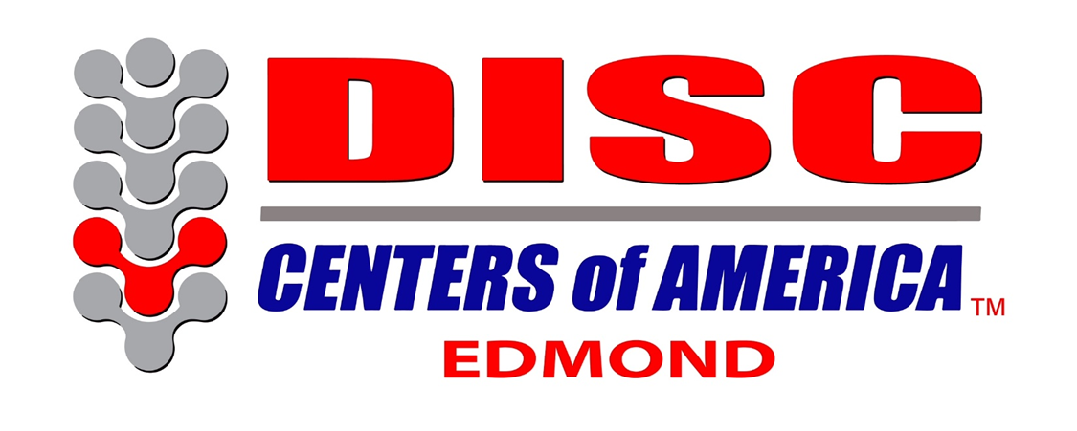

We are newly partnered with Disc Centers of America. Ask the front staff for more information.

Decompression-
Spinal decompression therapy, also known as non-surgical spinal decompression, is a practice that utilizes spinal decompression tables to relieve pain by creating a scenario in which bulging or herniated disc tissue is able to move back into place and heal, alleviating the pain this condition causes.
Spinal decompression therapy aims to help patients who suffer from debilitating pain due to bulging, degenerating, or herniated discs. It can also be used for the pain management and treatment of many causes of sciatica, injured or diseased spinal nerve roots, and worn spinal joints.
The therapy itself works to stretch the spine, using a spinal decompression table or other device, in order to create negative pressure and space within the disc to allow disc fluid to move back into place. This creates an environment in which the disc can receive more nutrients and therefore heal itself more quickly and effectively. The goal of spinal decompression therapy is to relieve the patient’s chronic back, arm, neck, and/or leg pain, and to heal the source of said pain.
Spinal decompression therapy is also referred to as non-surgical decompression therapy, since it is often used as a safe, affordable, and extremely effective alternative to spinal surgery. The distinction between surgical and non-surgical spinal decompression is an important one, as surgical spinal procedures are often considered a last option, while spinal decompression therapy is a safe treatment at any stage of back pain. The most common spinal decompression surgeries are laminectomy and microdiscectomy, which present a greater risk of complication or failure.

In Edmond location by appointment only.

